Date

Address of Recipient

Re: Cease and Desist Demand

Dear ,
The purpose of this letter is to review federal law regarding the use of products allowed under the FDA’s Emergency Use Authorization (EUA), which is based on the Nuremberg Code. Per the Nuremburg Code and the EUA, everyone must be fully informed and given the option to accept or refuse administration of experimental products. The EUA is used by FDA to allow the use of products in medical care that have not met FDA’s standard of approval, therefore, are considered to be experimental. This includes Covid-19 vaccines, PCR tests and non-surgical (cloth) face masks.
Federal law supersedes state and local law. Any organization coercing any individual to use or take these products is violating federal law and is open to lawsuits. Injuries that result from the use of these products compounds the violation.
The Nuremburg Code is the result of the Nuremburg Trials after WW II. Article 6 of the Nuremburg Code is a direct response to the horrific and deadly experiments carried out by Nazi doctors on Jewish prisoners in concentration camps. It states anyone participating in any medical experimentation (trial / study) must be allowed to give voluntary consent after being fully informed of the nature, duration and purpose of the experiment, the effects the experiment may have on his health and person and inconveniences and hazards to be reasonable expected.
As the EUA is federal law, states are not permitted to set their own mandates for vaccines, Covid-19 testing or the use of non-surgical masks in the general community. Police cannot arrest anyone for not following state mandates and state health agencies cannot penalize businesses as federal law preempts state law.
When a soldier is given an unlawful order, he is duty bound to ignore it. Using the defense he was simply following orders does not protect him from the legal consequences of following an unlawful order. While vaccine makers have been given total immunity from lawsuits due to any injuries resulting from the vaccine makers, businesses, schools and so on have no such protection. You are required to fully inform anyone entering your premises of your mandates, the risks of following your mandates, such as vaccine requirements, mask wearing and Covid-19 testing. If you choose to enforce the mandates, you can and will be held liable for the outcome.
Ignorance to the consequences of long-term mask wearing, requiring social distancing, quarantining individuals based on the outcomes of testing with an obscenely high false positive rate, and the Covid-19 vaccines have already caused great harm and will continue to cause ongoing health problems long into the future. Much of the public still have no knowledge of these facts due to massive censorship across all platforms: news outlets, social media and television programs.
The fact is, there is no one product that is absolutely safe for every individual in the world. Genetic traits of some groups of people could very likely make them more vulnerable to any one of the ingredients in the vaccines, causing severe injury or death. Severe vaccine injury is defined as being incapable of working and requiring assistance for daily tasks. Forcing a one-size fits all approach to every individual will likely result in a percentage of the population dying or being injured. Until the science and medical communities are able to determine such vulnerabilities, no one can be legally forced to be a guinea pig.
To that end, just a fraction of the knowledge that has been withheld from the public is within the attached document: links to scientific studies, interviews with the top doctors and scientists from around the world. You must immediately cease and desist all requirements of mask wearing on the premises, Covid-19 testing or forcing vaccinations to continue employment or use of the facilities.
As you review the information, please keep the following in mind:
- The CDC admitted in July and December 2020 they had not isolated the Covid-19 virus. In fact, no one in the world has done so to date.
- The CDC admitted in December 2020, the RT-PCR test cannot definitively diagnose Covid and cannot rule out some other cause for a positive result. The WHO also admitted in December 2020 the RT-PCR is flawed. July 2021, the CDC stated the RT-PCR would be phased out by the end of 2021 and the test was to be replaced with another that can differentiate between Covid-19 and the annual flu. Kary Mullis, the inventor of the RT-PCR as a research tool frequently declared it cannot diagnose any illness.
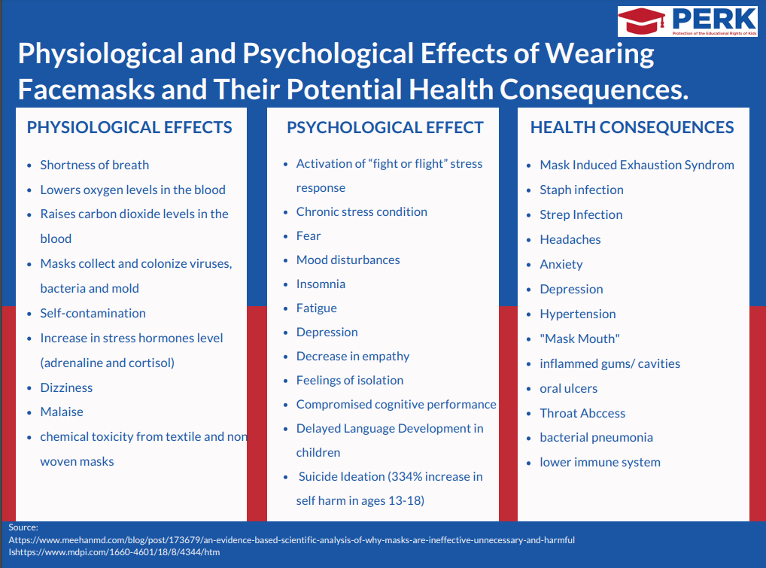
- The WHO admitted cloth masks are virtually ineffective at blocking Covid-19 and may, in fact, increase the chance of illness. In addition, mask wearing for hours on end, multiple days per week leads to dental problems, which in turn can lead to heart attacks and strokes.
- Vaccines should never be the first line of defense against any disease when safe and effective (and inexpensive) treatment is available, especially when the population is able to build up their immune system ahead of exposure with vitamins D3, C, zinc and quercetin.
Making hydroxychloroquine and ivermectin available to the vast majority of the public, while ensuring they have no medical condition that would contra-indicate such treatment within in the first 48 hours would have reduced Covid-19 deaths by up to 94% of their current numbers. Contrary to claims, over 300 studies prove these are safe and effective, especially when given early.
- Big Pharma ensured it cannot be sued for any injuries or deaths resulting from the vaccines, but you can be sued for enforcing experimental products that cause harm.
This will serve as your legal notice to cease and desist all further action described within this document. Any harm inflicted on any person on the premises, such as, but not limited to physical or mental health problems that arise from continuing mask mandates or requiring Covid-19 vaccines or testing will subject you and your organization to face legal sanctions under applicable Federal, State and Local laws. I intend to keep a log of any contacts you make with me after you receive this notice.
I am sure you are tempted to laugh off this cease and desist from an average American with no money for an attorney, but do be aware this document and evidence has been publicized across multiple outlets. A database of cease-and-desist letters is being created from Americans across the nation and will be made available to any and all attorneys. I will be keeping a record of all interactions between us, which will also be publicized and submitted to the same database.
Americans all across this country are sending similar cease and desist documents to hospitals and doctors in their vicinty, schools, employers, airlines, businesses, etc. It will be noted which organizations chose to ignore the evidence within this document and put money before the health of their employees, students or customers.
Please give this very important matter the utmost attention.
Sincerely,

Your Name
Your Address

